Name _______________
IRAT
INDIVIDUAL READINESS ASSURANCE TEST
Session #9
2-17-14
- Please write in the space below the definition of a likelihood ratio.

- Chose the most accurate statement relating to the pre-test probability
  - The pre-test probability of disease is required to calculate the post-test probability of disease
  - The pre-test probability of disease is equivalent to sensitivity/(1 – specificity)
  - The pre-test probability of disease is required to calculate the NNT
  - The pre-test probability of disease is equivalent to (1-sensitivity)/specificity

- One of your friends from college asked you to describe sensitivity and specificity. Choose the best answer
  - Sensitivity and specificity are characteristics of a test which describe the true positive and negative rates, respectively
  - Sensitivity and specificity are characteristics of a test which describe the treatment benefit and detriment rates, respectively
  - Sensitivity and specificity are characteristics of the gold standard which describe positive and negative post-test probabilities, respectively
  - Sensitivity and specificity are characteristics of a test which describe the ability of a test to detect disease incidence and prevalence, respectively

- For any given test result, a likelihood ratio is
  - the probability that the patient has the disease subsequent to running the diagnostic test
  - the probability that the patient comes from the sick rather than the healthy population
  - the probability that the patient is a true positive rather than a false positive
  - the probability that the patient has the disease prior to running the diagnostic test

- Select the statement that best describes the requirements for determining the probability of disease, i.e., the post-test probability. The post-test probability may be calculated from
  - the likelihood ratio and the NNT
  - the post-test and pre-test sensitivities and specificities
  - the pretest probability and the likelihood ratio
  - the likelihood ratio or the sensitivity and specificity

- Using the nomogram, below, what are the post-test probabilities of a UTI in a patient who tests positive and in a patient who tests negative with a new rapid urinalysis? Assume the prevalence of UTI is 10%, the +LR is 10, and the –LR is 0.05.
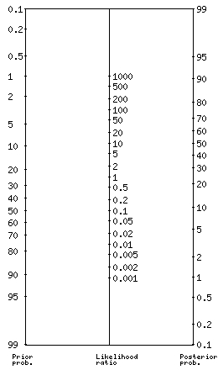

- 6%/1%
- 93%/0.1%
- 16%/5%
- 53%/0.5%

